Introduction

The embedded system project requires each group to complete a white-line-following buggy by designing, wiring and programming. The whole project is split into Semester 1 for designing and Semester 2 for implementation.

This proposal document is a summary for semester one and marks the design activities end. In the document, multiple aspects will be represented to summarize the work of semester 1. The technical overview part mainly represents the contribution of theoretical knowledge, including design decisions, motor and sensor characterisation, software system design and chassis design. The understanding of this theoretical knowledge can help us complete the implementation part in the second semester.

The team organization section describes the team's situation, which includes the team rule and responsibility, and how a team works in the whole project. More precisely, it contains the work distribution and the evidence of the weekly meeting.

Planning and budget part describes the summary of important aspects of the whole project. It contains the Gantt Chart, risk assessment, budget and expected total cost of the Buggy.

The whole project aims to deliver a line-following buggy which operates as fast as possible to complete the race without accidents. Few deliverables and milestones should be done in the project. For example, each completed reports and demonstration are considered deliverables; the proposal document, technical demonstration and final report could be milestones.

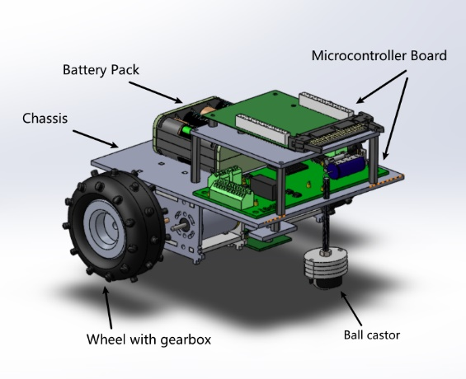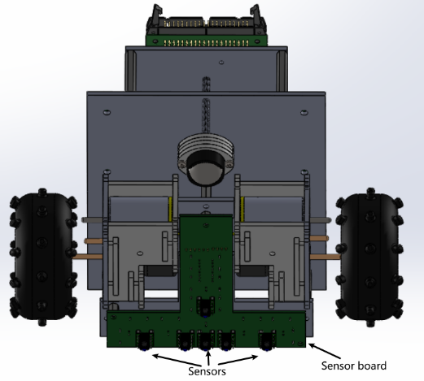Figure 1.1 and figure 1.2 shows the overview of the Buggy inside view and bottom view. The model shows all components of Buggy, including battery pack, 3-layered chassis, wheel, motor, gearbox, ball castor, microcontroller board, sensor board and sensors.

Figure 2

Figure 1